Tiingo API
OTHER FEATURES TAB?
- Senate
- Crypto
- etc
DIVIDEND/EARNING/STATEMENT ANALYSIS TABS?
Quartely info only. Worth it???

Stock price data: DONE
Financial Modelling Prep API

MARKET PERFORMANCE TAB
- Sector historical: DONE
- Market Index
- Sector PE ratio: DONE
COMMODITIES TAB
- Commodities daily: figure out which commodities (gold etc) matter for the tech stocks in question and pull data on them: DONE
FOREX TAB
- Forex daily: figure out which currencies relative to USD matter for the tech stocks in question and pull data on them: DONE
NEWS TAB
- Stock news: DONE
- Press release news: DONE
- Historical social sentiments: DONE
ECONOMICS DATA TAB
- Treasury rates: DONE
- Economic indicators – inflation rate: DONE
TECHNICAL INDICATORS TAB
- SMA, EMA, Bollinger bands etc.
- Figure out which indicators work best for our tech stocks and pull data on them and possibly combine them in one excel file: DONE

DATASETS MERGING
- Combine all datasets (stock price, news, forex, market performance, commodities etc) by date for each company separately. All date formats across different datasets should match.

- Include Nvidia features (exact features to be determined) into each company’s final dataset.
MODEL ESTIMATIONS
- First attempt on LSTM model
- Other attempts on models including the Random Forest, GRU and Black-Scholes model
- Ensemble models
- Evaluating and comparing models
MARKET PERFORMANCE TAB
- Combine data into one excel file for each company
NEWS TAB
- Aggregate each news type to daily data: DONE
- Merge all 3 types to composite score? : DONE

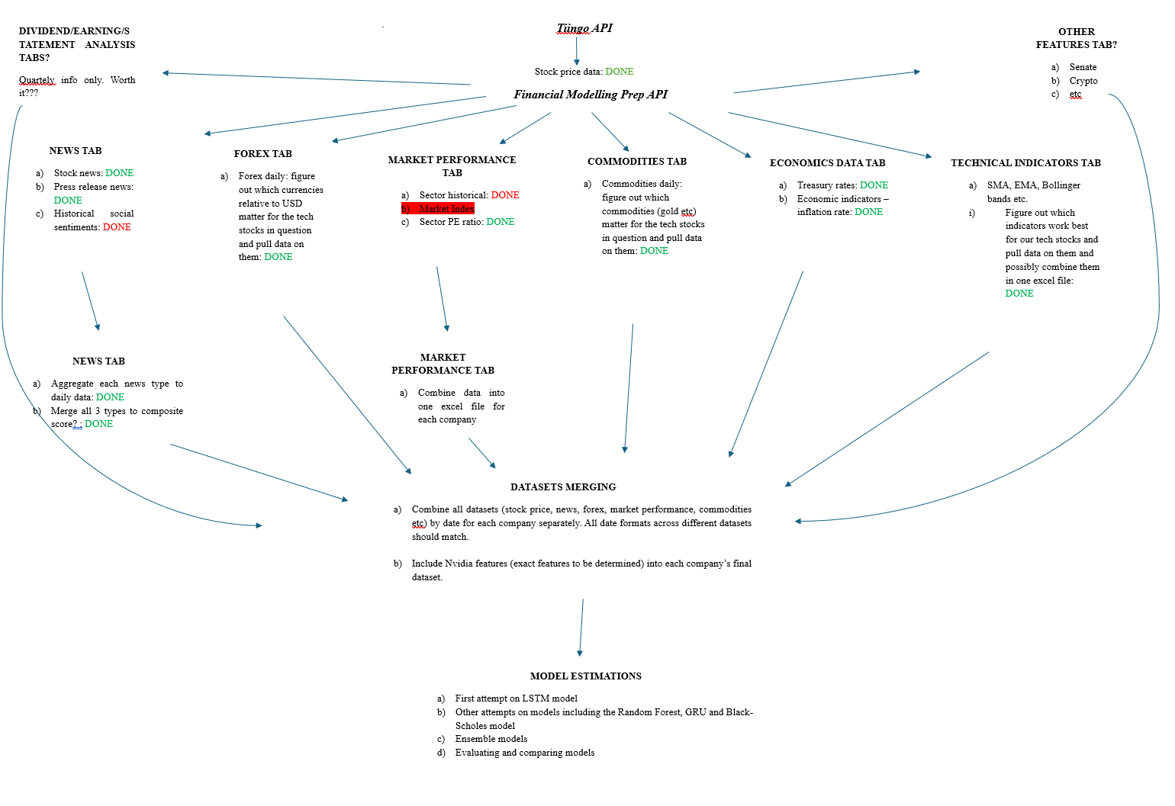

DATASETS REQUIRED FOR EACH COMPANY

- Stock price datasets.
- Merged technical indicators.
- Complete news data (includes news, press releases and social sentiments).
- Forex datasets.
- Commodity datasets.
- Treasury rates dataset
- Inflation rates dataset
- Sector_pe_ratio dataset
- Historical_sector_performance dataset.

